Contents

1 🔧What’s New 2

2 🚀 Fixed Defects 2

3 ⭐ Improvements 3

4 🚀 Deployments 4

4.1 Infrastructure 4

4.1.1 File Updates 4

4.1.2 Deployments 4

4.2 CRM 5

4.2.1 Import TASMU_CPM_Core solution manually 5

4.2.2 Deployment 5

4.2.3 CRM Post Deployment Verification 5

4.2.4 CRM Email Template Links Update 5

4.2.5 Survey Email Templates 5

4.3 Web Apps 6

4.4 Platform APIs 6

4.5 Mobile 6

5 💻 Reviewers 7

6 Appendix 8

6.1 Post Deployment Verification 8

6.2 Running Pipeline from Tags 8

Release Notes

# 🔧What’s New

New user stories delivered:

| **ID** | **Title** | **State** |
| --- | --- | --- |
| [35905](https://dev.azure.com/TASMUCP/TASMU%20MSI/_workitems/edit/35905) | As a developer, I need to update the UX of CMS related email templates so that it is in-lined with latest approved email template design | DOD Ready |
| [35967](https://dev.azure.com/TASMUCP/TASMU%20MSI/_workitems/edit/35967) | As a developer, I want to update the UX of email templates for CRM automated emails so that it is in-line with latest approved email template design | DOD Ready |
| [36062](https://dev.azure.com/TASMUCP/TASMU%20MSI/_workitems/edit/36062) | As a developer, I need to create About TASMU HTML pages which were approved so that additional formatting options can be utilized | DOD Ready |

# 🚀 Fixed Defects

The following bugs reported in SIT are addressed in the current interim build –

| **ID** | **Title** | **Severity** | **Priority** |
| --- | --- | --- | --- |
| [35912](https://dev.azure.com/TASMUCP/TASMU%20MSI/_workitems/edit/35912) | FN-Portal-Arabic-While selecting country in Billing Address, countries are not alphabetically sorted | 4 - Low | 2 |
| [35970](https://dev.azure.com/TASMUCP/TASMU%20MSI/_workitems/edit/35970) | B2C - Order Subscription - Field 'Zone' is not mandatory for 1st try of subscription at service | 3 - Medium | 2 |
| [36017](https://dev.azure.com/TASMUCP/TASMU%20MSI/_workitems/edit/36017) | NF-Localization-B2B- About TASMU is not fully in Arabic in the Menu of home page | 3 - Medium | 2 |
| [36079](https://dev.azure.com/TASMUCP/TASMU%20MSI/_workitems/edit/36079) | NF- Localization- B2B - Title of section not correctly written | 4 - Low | 2 |
| [36085](https://dev.azure.com/TASMUCP/TASMU%20MSI/_workitems/edit/36085) | NF-Localization- B2B- On Home page View all is in English for Arabic version | 3 - Medium | 2 |

# ⭐ Improvements

1. Email template design updates for CMS related emails
2. About TASMU Links update in portal.
   1. Team is removed.
   2. Enabling digitalization and leadership is added.

[Please clear the local storage cache while testing]

1. Remove multiple API calls during configure order screen.
2. Updated SaveOrder call to pass English Values instead of GUID’s used by ITSM.

# 🚀 Deployments

## Infrastructure

Pull Request – [Pull request 7031: Merge TASMU CP into TASMU MSI - 25 May 2021 - Repos (azure.com)](https://dev.azure.com/TASMUCP/TASMU%20MSI/_git/infra/pullrequest/7031)

### File Updates

1. Add/Update following parameter files -

|  |  |  |  |
| --- | --- | --- | --- |
| **Module** | **Parameter Files** | **Action** | **Properties** |
| LogicApp | logic-<sub>-apps-intgbaprl-<env>-we-01  logic-<sub>-apps-intrsl-<env>-we-01  logic-<sub>-apps-intaprv1-<env>-we-01 | Update | Refer PRs : [6984](https://dev.azure.com/TASMUCP/TASMU%20Central%20Platform/_git/infra/pullrequest/6984) , [7003](https://dev.azure.com/TASMUCP/TASMU%20Central%20Platform/_git/infra/pullrequest/7003) and [7016](Pull%20request%207016:%20Updated%20cms%20email%20templates%20-%20Repos%20(azure.com) for the changes required to be incorporated. |
| StorageAccount | st<sub>glocacmwe01  (refer cpd file) | Update | allowBlobPublicAccess,  minimumTlsVersion,  blobContainers,  and diagnostic settings |

### Deployments

1. Run the following pipelines -
   1. CD-rg-<sub>-glob-acm-we-01-Master-Release
   2. CD-rg-<sub>-apps-int-<env>-we-01-Master-Release
   3. CD-AppConfigurations-Master-Release

## CRM

### Import TASMU_CPM_Core solution manually

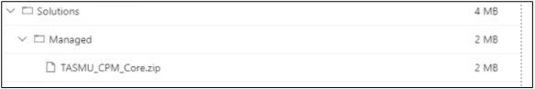

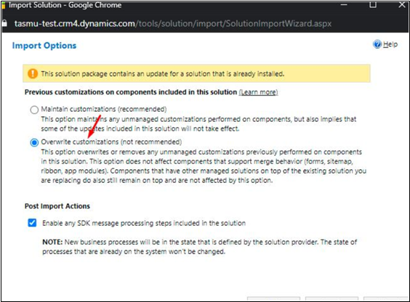

### Deployment

|  |  |
| --- | --- |
| **Build Id** | **Pipeline Name** |
| 43699 | [CD-CrmPlatform-Release](https://dev.azure.com/TASMUCP/TASMU%20Central%20Platform/_build/results?buildId=43699&view=results) |

### CRM Post Deployment Verification

[Verify workflows and business rules are activated from deployment guide](https://dev.azure.com/TASMUCP/TASMU%20Central%20Platform/_wiki/wikis/TASMU-Central-Platform.wiki/137/Dynamics-365-Deployment-Guide) (Refer 5.16 section)

### CRM Email Template Links Update

[Link to be changed in Email templates in CRM and Images needs to be uploaded for Prod](https://dev.azure.com/TASMUCP/TASMU%20Central%20Platform/_wiki/wikis/TASMU-Central-Platform.wiki/137/Dynamics-365-Deployment-Guide?anchor=5.17-email-templates-in-crm-and-images-needs-to-be-uploaded-for-prod) (Refer 5.17 section)

### Survey Email Templates

The manual steps will be informed in call.

## Web Apps

|  |  |
| --- | --- |
| **Tag** | **Pipeline Name** |
| SIT_Web_25May2021 | [CD-WebApps-Prd-Release](https://dev.azure.com/TASMUCP/TASMU%20Central%20Platform/_build?definitionId=1020) |

## Platform APIs

|  |  |
| --- | --- |
| **Tag** | **Pipeline Name** |
| SIT_API_25May2021 | [CD-PlatformAPIs-Prd-Release](https://dev.azure.com/TASMUCP/TASMU%20Central%20Platform/_build?definitionId=1021) |

## Mobile

|  |  |  |
| --- | --- | --- |
| **Platform** | **Build Id** | **Pipeline Link** |
| Android | 43311 | [Pipelines - Run 20210520.3 (azure.com)](https://dev.azure.com/TASMUCP/TASMU%20Central%20Platform/_build/results?buildId=43311&view=results) |
| iOS | 43312 | [Pipelines - Run 20210520.3 (azure.com)](https://dev.azure.com/TASMUCP/TASMU%20Central%20Platform/_build/results?buildId=43312&view=results) |

# 💻 Reviewers

|  |  |
| --- | --- |
| Prepared By | Manvir Kaur, Sumit Gupta |
| Company name | Microsoft |
| Reviewed by | Ravi Sankar Pillutla, Anil Erkek, Subhajit Chatterjee, Gareeb Navas T M, Mecit Atmaca |
| Approved by | Ashwani Sharma |

# Appendix

## Post Deployment Verification

1. Function Apps Running
2. <https://func-cpp-apps-ckan-pre-we-01.azurewebsites.net/>
3. <https://func-cpp-apps-qnasync-pre-we-01.azurewebsites.net/>
4. <https://func-cpp-apps-luistra-pre-we-01.azurewebsites.net/>
5. <https://func-cpp-apps-intbpa-pre-we-01.azurewebsites.net/>
6. <https://func-cpp-apps-intntf-pre-we-01.azurewebsites.net/>
7. <https://func-cpp-apps-pt-pre-we-01.azurewebsites.net/>
8. Marketplace Portal - <https://marketplace.pre.sqcp.qa/en/>
9. Bot – Chat with bot on marketplace
10. My Tasmu Portal - <https://mytasmu.pre.sqcp.qa/en/>
11. Account Portal - <https://account.pre.sqcp.qa/en/>
12. Admin Portal Portal - [https://cpadmin.pre.sqcp.qa](https://cpadmin.pre.sqcp.qa/)  (Login screen should come)
13. API Config access - <https://api.pre.sqcp.qa/config/api/feature>
14. Open Data Portal - <https://opendata.pre.sqcp.qa/>

## Running Pipeline from Tags

